Supplementary Material

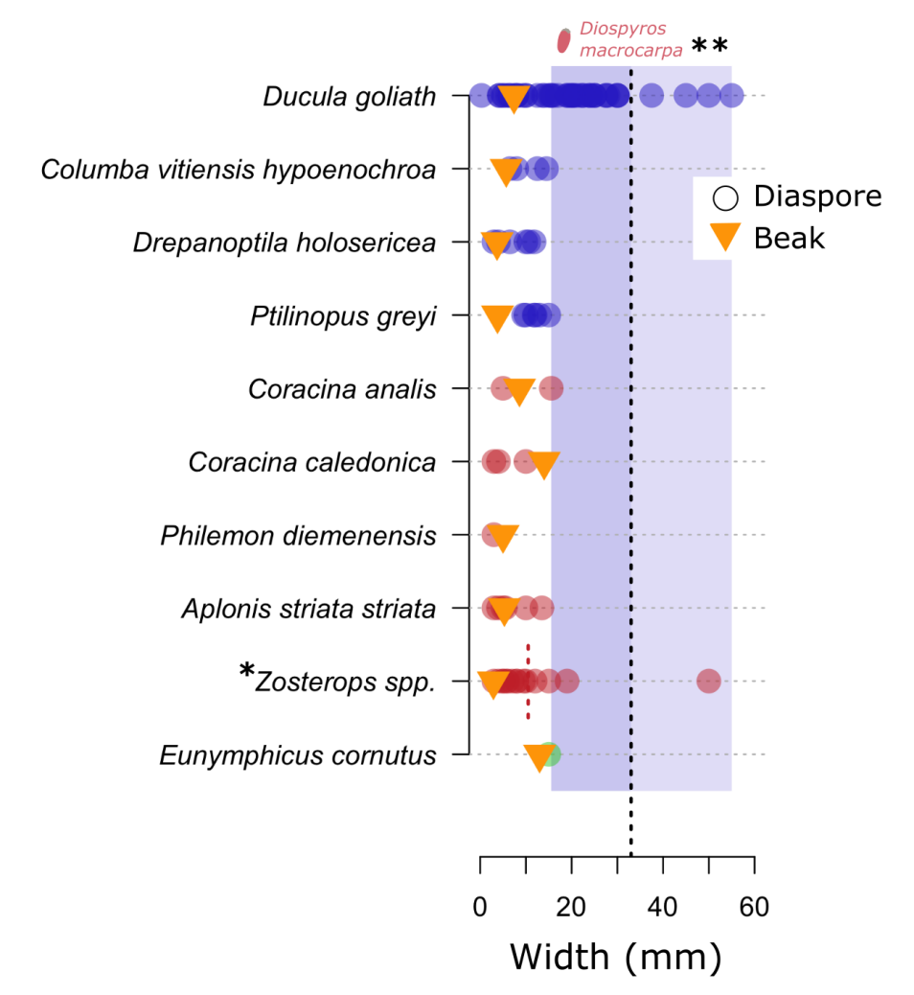

**Figure S2** Observations of diaspore consumption by birds. Each point corresponds to an observation of a plant species consumed by a bird species. The width of the diaspore and the beak correspond to average values. \**Zosterops spp.* includes *Z. lateralis grisenota* Gray and *Z. xanthochrous*, these species peck and don't swallow diaspores wider than 10.5 mm (vertical red dotted line in A, Boissenin et al. 2006). **Widest fruit (33 mm) observed to be swallowed by *D. goliath* in experimentation (vertical black dotted line in A and B, Munzinger, unpublished data).  *D. goliath* has also been observed to consume three species with diaspores wider than 33 mm on average (*Endiandra baillonii* (Pancher & Sebert) Guillaumin, Lauraceae, *Syzygium jambos* L. (Alston) and *S. neolaurifolium* N. Snow & Byng, Myrtaceae). However, the fruits actually consumed by the birds were probably smaller than the average value for these species.